

Next Meters Global - PROCESS FLOW DOCUMENT - RECORD TO REPORT

Paapri Cloud Technology
Company Information:

Login to NetSuite using Administrator Role. Navigate: Setup -> Company -> Company Information

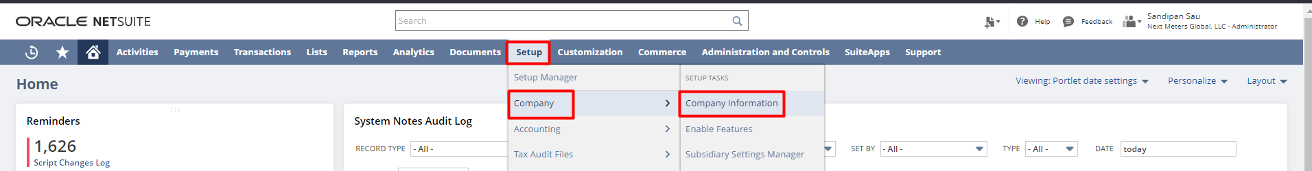

The Company Information page is where an administrator or other user with setting up company permission can enter basic identifying information for an account like company name, company logo, company return email address, fax, company address, EIN, SSN, or TIN Number, etc.

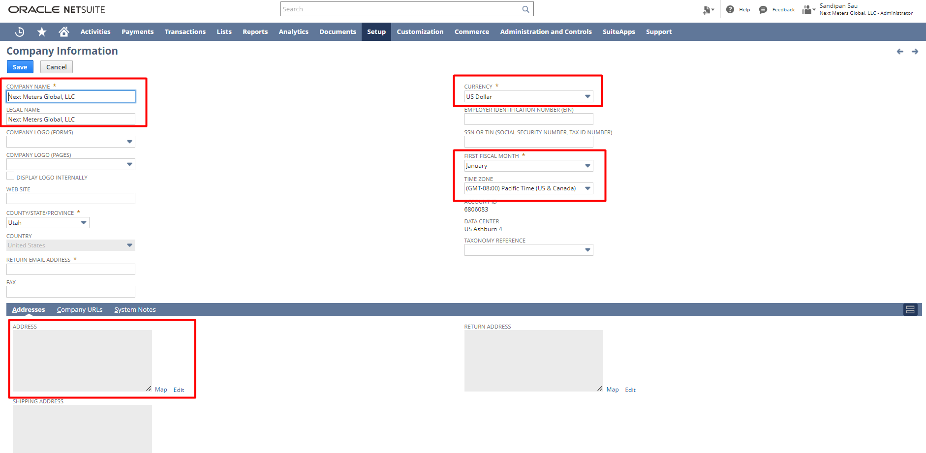

To add/edit a company address, click on the Edit button. A pop-up with all the address fields will open where the address can be entered.

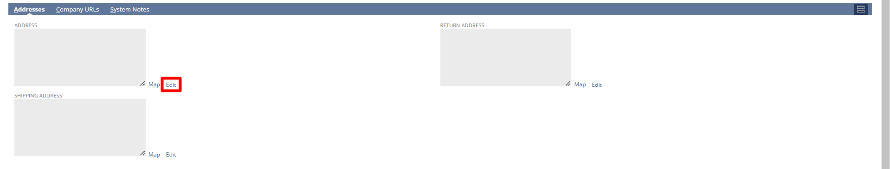

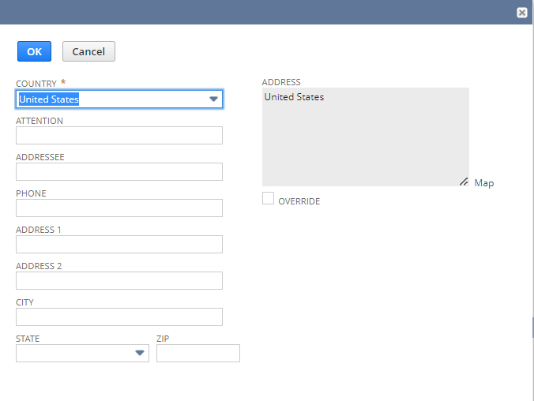
Enable Features:

Login to NetSuite using Administrator Role. Navigate: Setup -> Company -> Enable Features

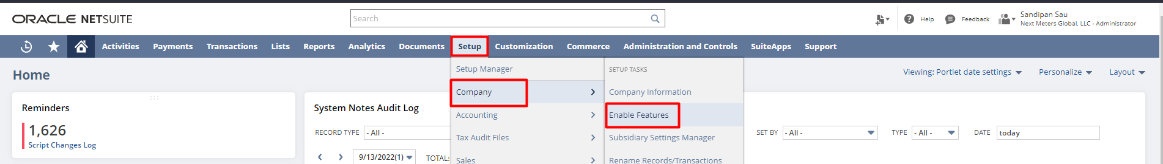

Here you can able to activate features
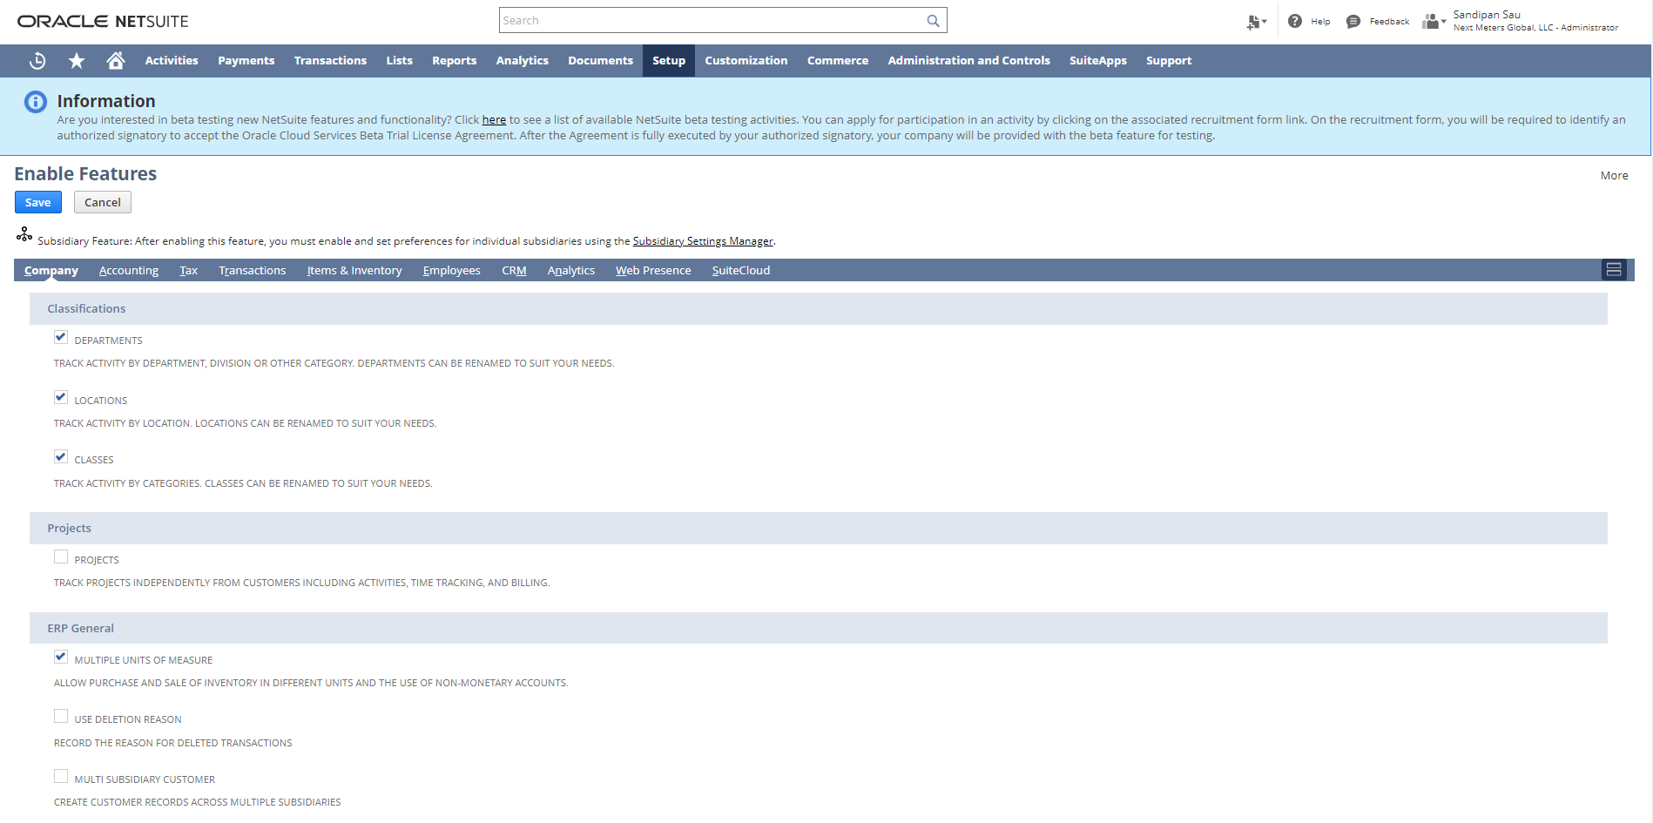

Rename Records/Transactions:

Login to NetSuite using Administrator Role. Navigate: Setup -> Company -> Rename Records/Transactions

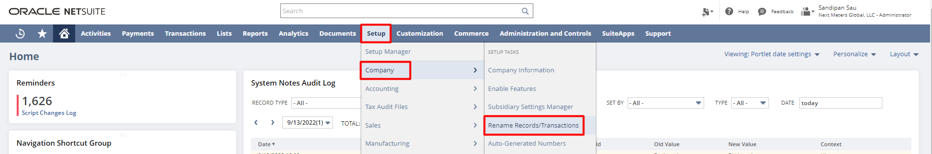

You can change the names of your records and transactions from NetSuite default names to names that fit the terminology of your company on Rename Records/Transactions page. On this page, you can also change the names of the account types used in NetSuite

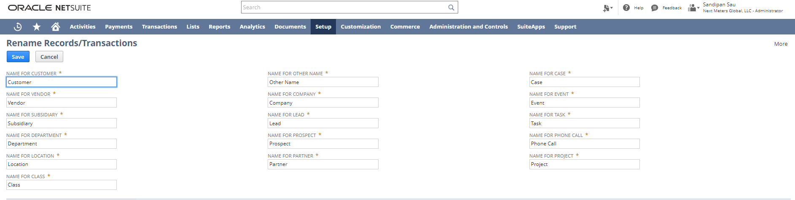
In the Rename Records/Transactions page body, you can change the names of standard NetSuite non-transactional record types.

On the Transaction Names subtab of the Rename Records/Transactions page, you can change the names and abbreviations of standard NetSuite transaction types.
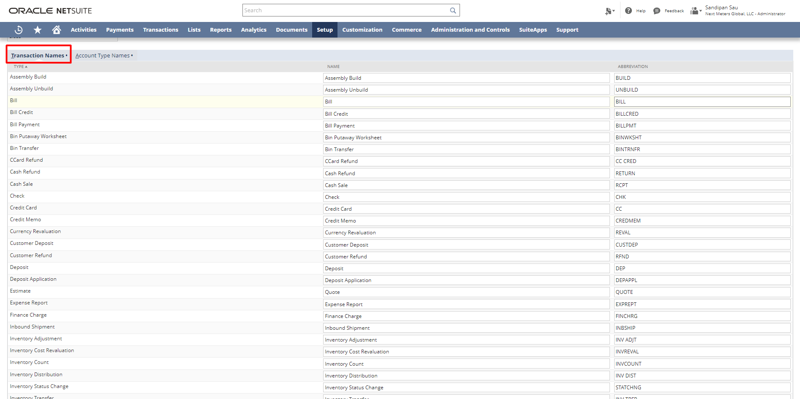
On the Account Type Names subtab of the Rename Records/Transactions page, you can change the names of standard NetSuite account types.

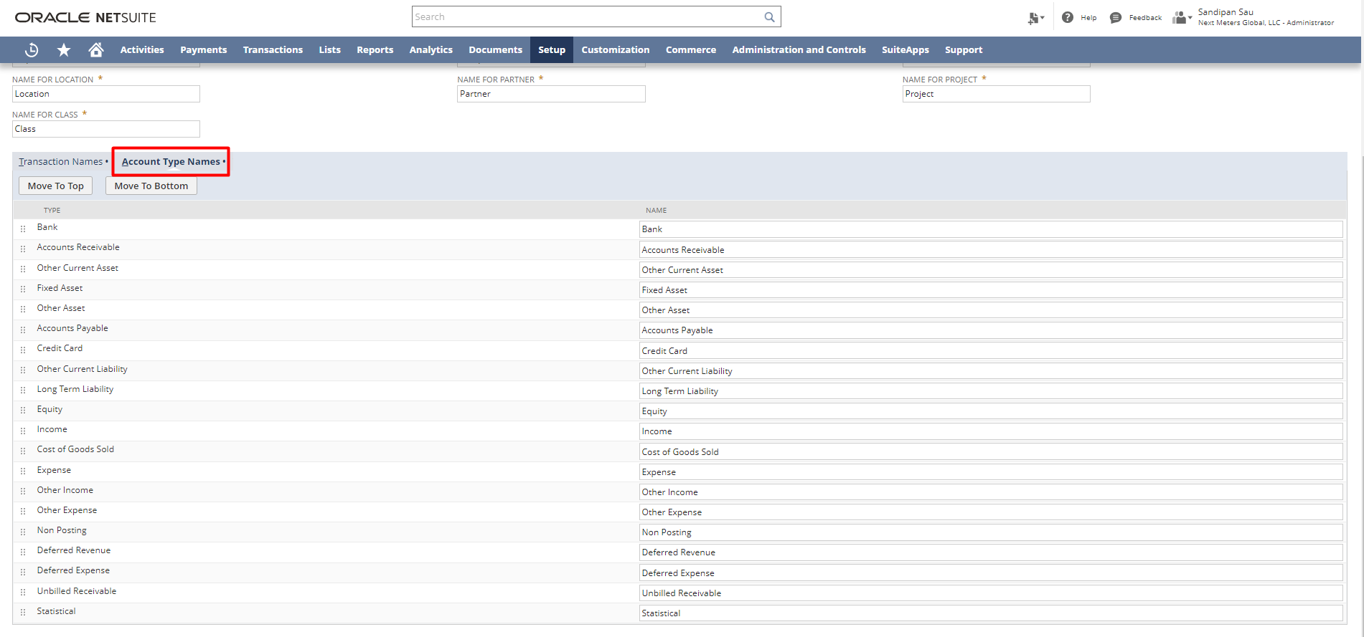

Auto-Generated Numbers:

Log in to NetSuite using Administrator Role. Navigate: Setup -> Company ->Auto-Generated Numbers

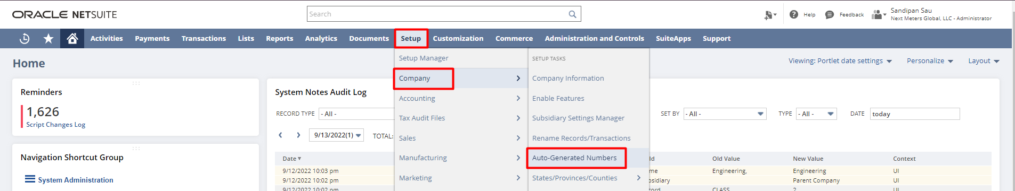

The Set-Up Auto-Generated Numbers page enables you to choose the record types that should be automatically numbered in the order in which they are created. On this page, you can also add prefixes and suffixes to auto-generated numbers. Prefixes and suffixes are useful in determining a record, transaction, or document’s type and estimated age at a glance

For example, you may choose to enable auto-generated numbering for the customer record type in your account and prefix the number with CUST. Each time you add a new customer record, the record number increases sequentially by one. When you view your customer list, you can quickly see that CUST0025 is a newer customer than CUST0004.

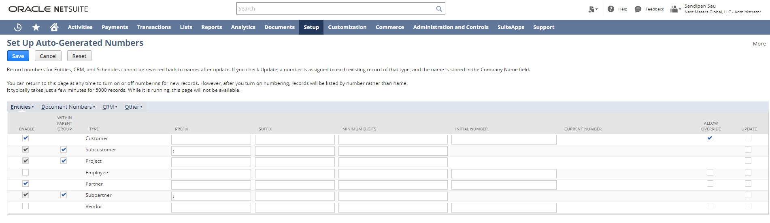

General Preference:

Log in to NetSuite using Administrator Role. Navigate: Setup -> Company ->General Preferences

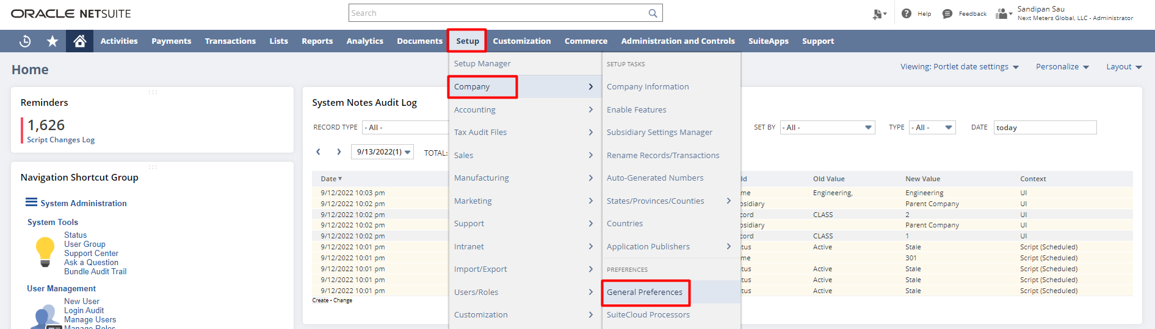

An administrator or another user with the Set Up Company permission can set company Preferences for how information is input and processed in NetSuite, on the General Preferences page. These Preferences apply to all users in the account.

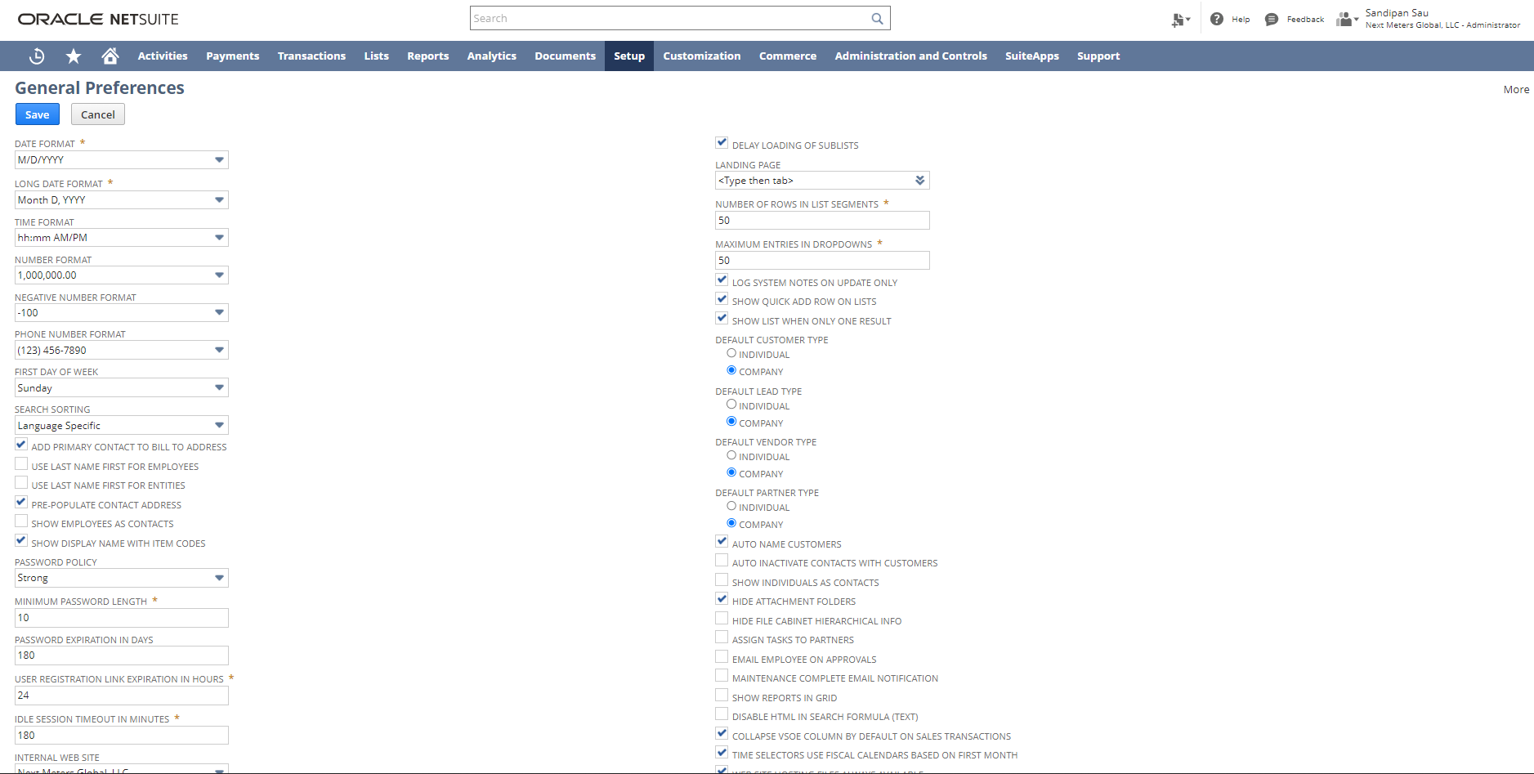
Accounting Preferences:

Log in to NetSuite using Administrator Role. Navigate: Setup -> Accounting -> Accounting Preferences

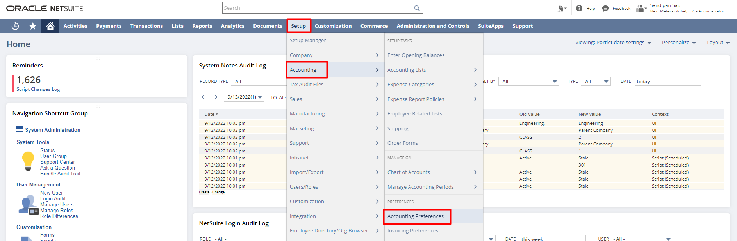

In the Accounting Preferences, we can make the changes for the Accounting-related requirements.

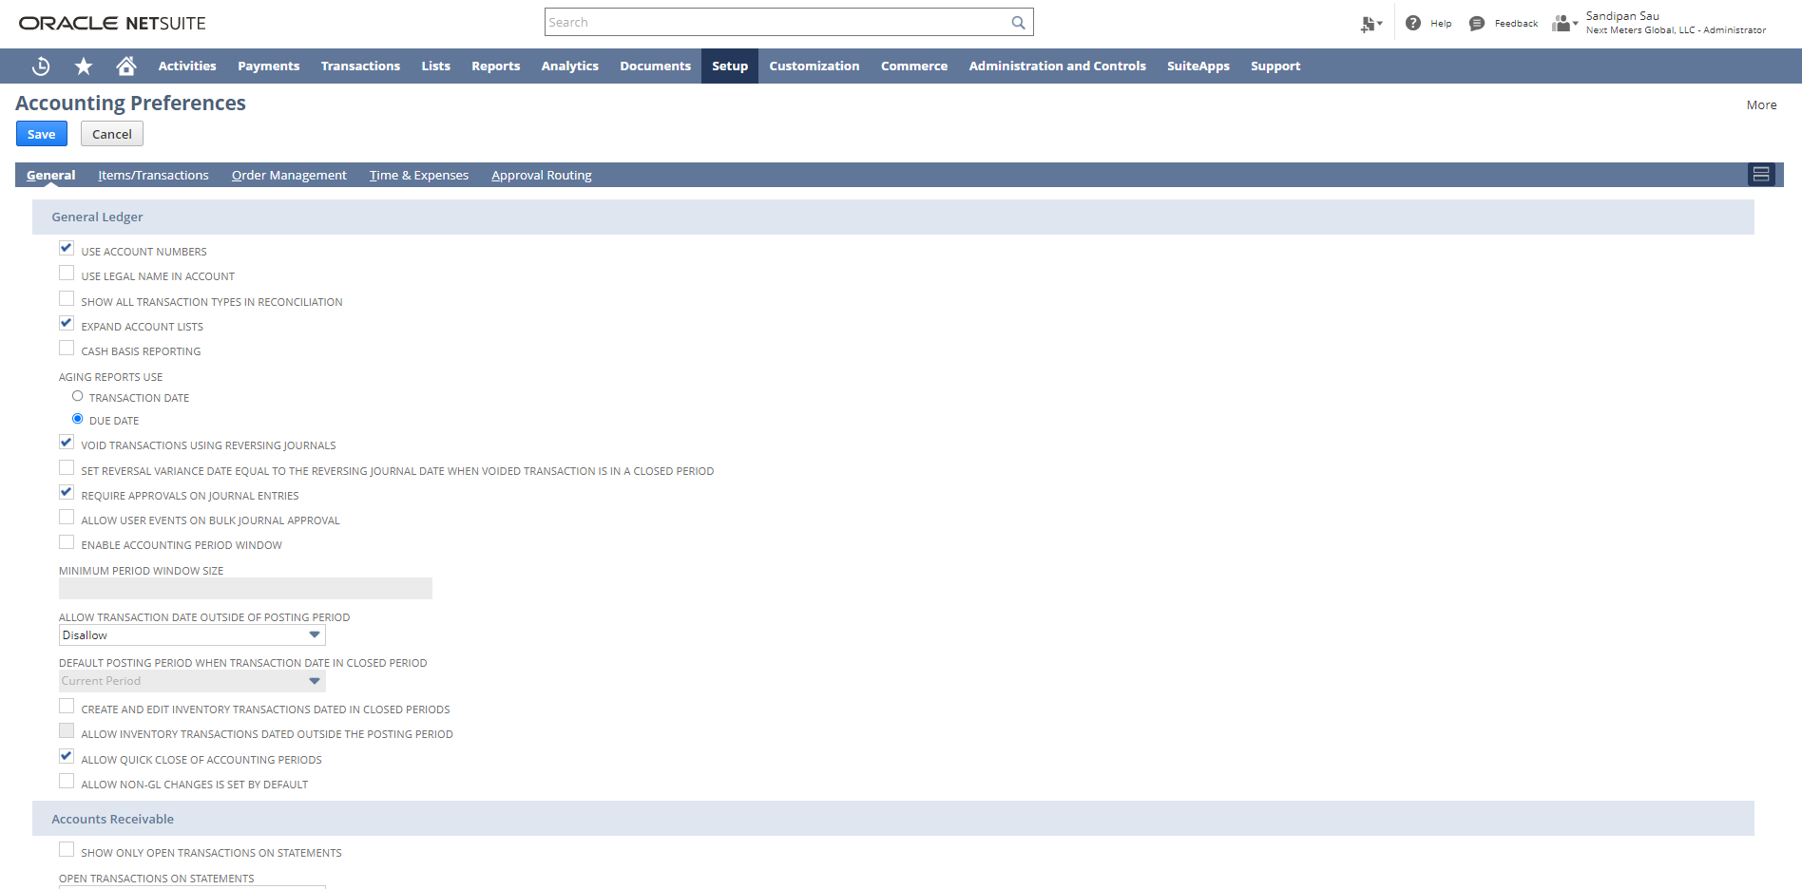

Set Preference/User Specific Preference:

Log in to NetSuite. Navigate: Home Icon -> Set Preferences

This section of NetSuite Basics describes the preferences that are available to you as a NetSuite user.
The Set Preferences page displays options for most aspects of your NetSuite account. These preferences enable you to set up your NetSuite account to fit your needs. Your user preferences are constrained by the features enabled for your account, company account-level preferences, and the role-based dashboards that are set up by your account administrator.
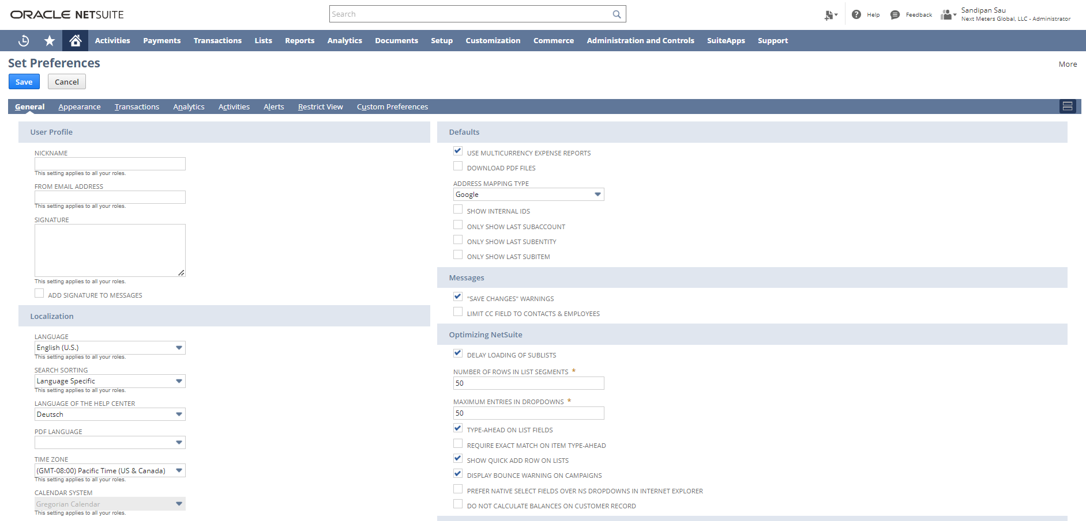

Duplicate Detection:

Login to NetSuite using Administrator Role. Navigate: Setup -> Company -> Duplicate Detection

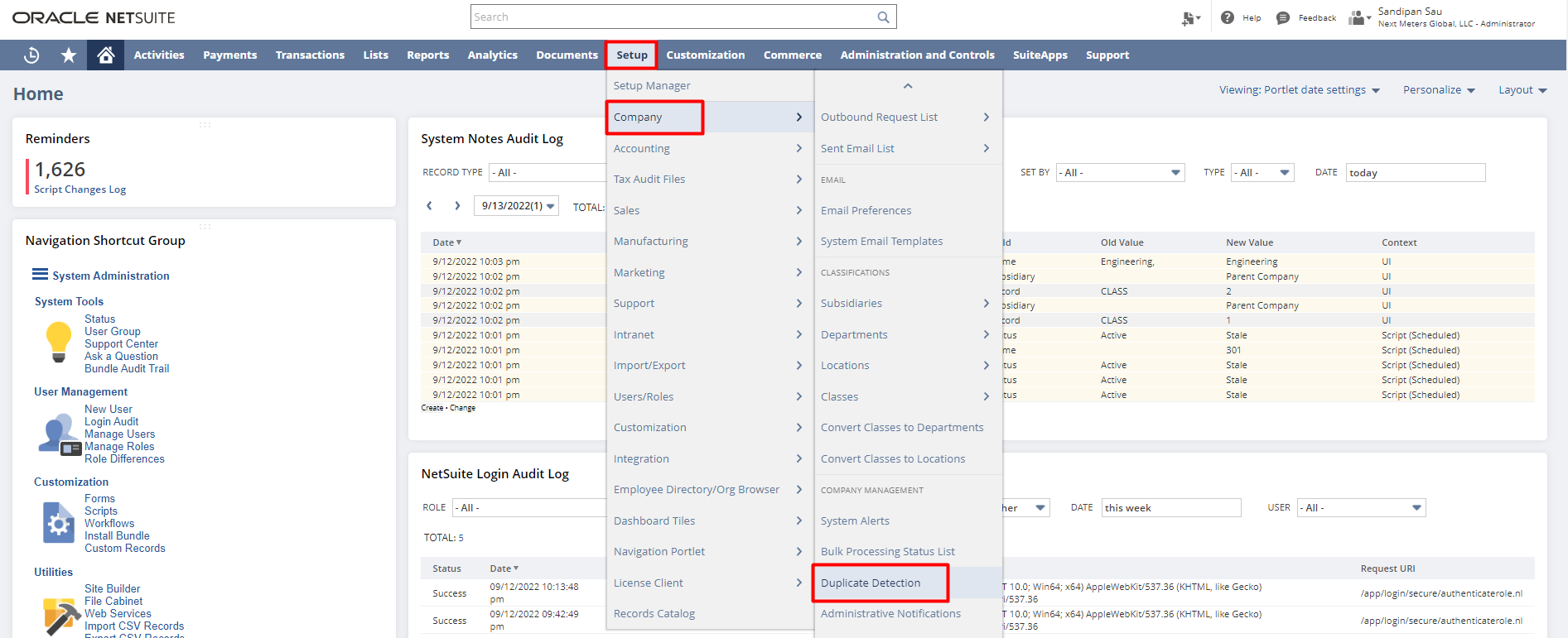

The Duplicate Detection & Merge feature helps you find duplicate records in your NetSuite account and use the information in them to create a single record.

Four types of records support duplicate matching: Customer, Vendor, Partner, and Contact.
With this feature enabled, you receive a notification before saving a record that might be a duplicate.

Notification occurs in two ways:
The first way, when you create a new record and enter matching data in fields the administrator set up as duplicate criteria, a warning appears at the top of the record with a link to the potential duplicates. If you have permission to view those records, you can click the link to resolve these matching records

The second way, when you add a record from a list by using Quick Add or use the Edit button to make changes to a record that would make it a duplicate, you receive a popup warning.

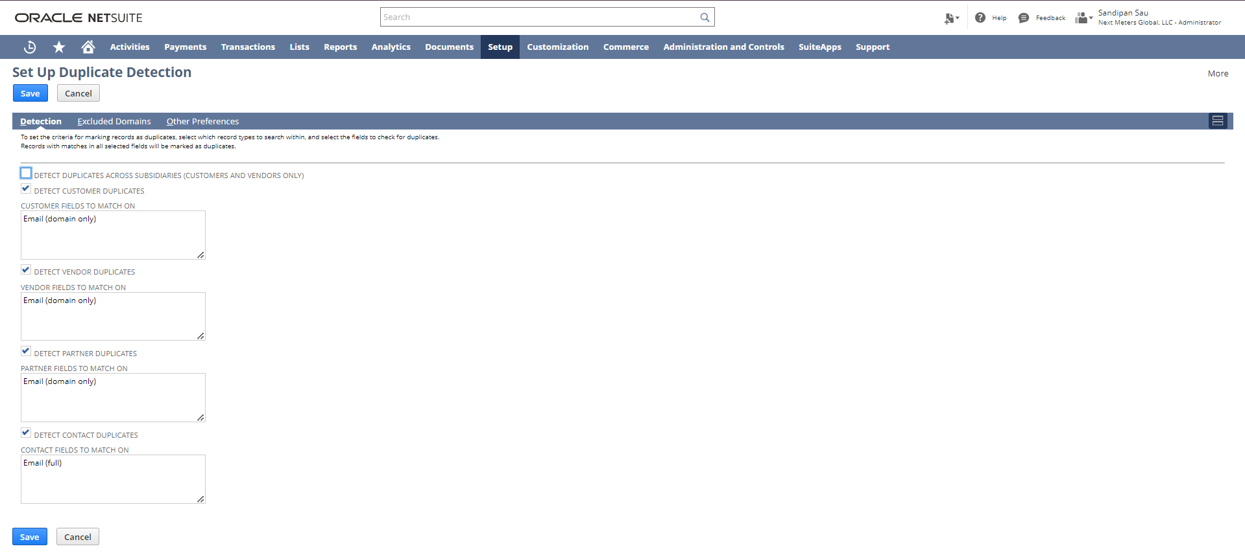
From the Other Preferences tab, you can select how you want to resolve duplicate records or whether you want to see a duplicate warning popup on the record.

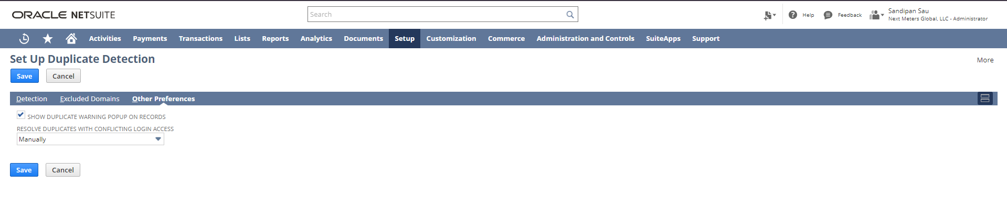
Setup Accounting Periods:

Log in to NetSuite using Administrator Role. Navigate: Setup -> Accounting ->Manage Accounting Periods

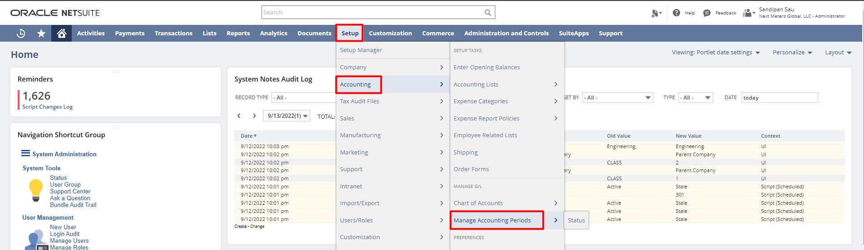

You have the option of setting up a single accounting period at a time or generating all periods for a full year using the Set-Up Full Year button. The best practice recommendation is to use Set Up Full Year to generate all periods and to roll up the hierarchy for a full year. You must have at least the Edit level of the Manage Accounting Periods permission to set up accounting periods.

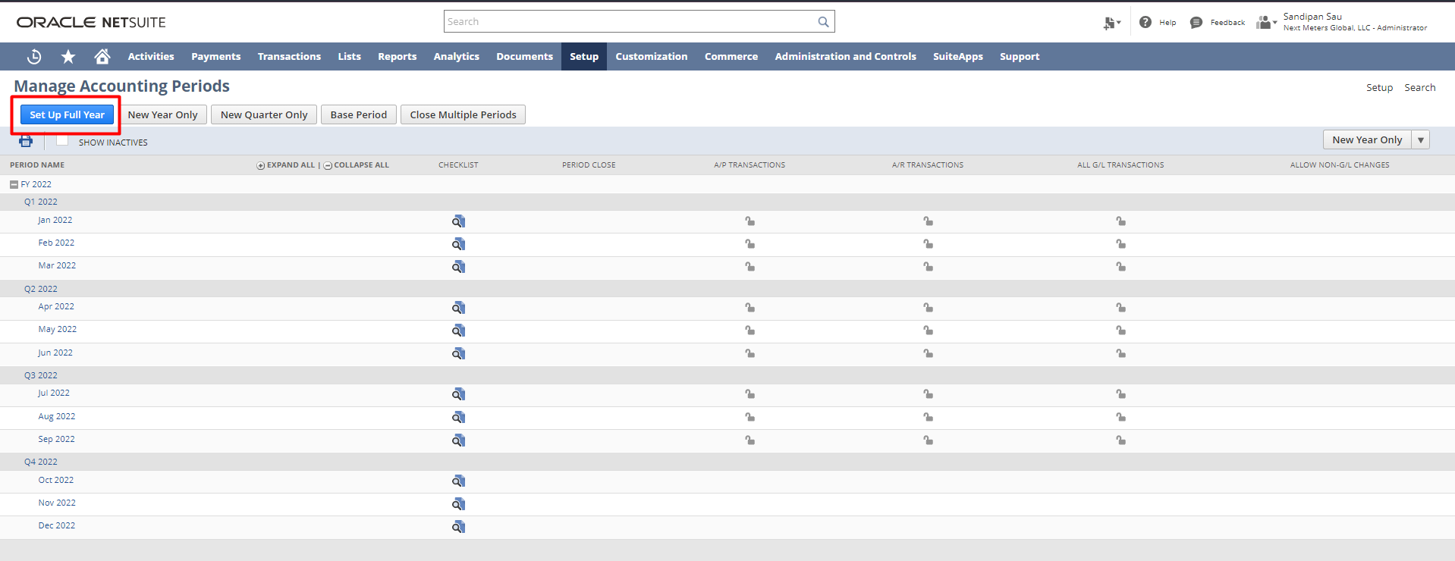

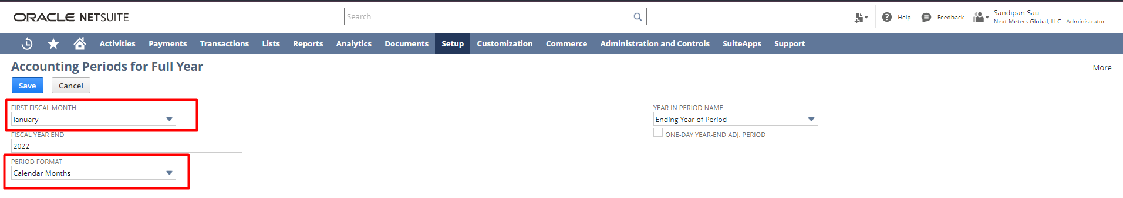

Accounting Period Close:

Log in to NetSuite using Administrator Role. Navigate: Setup -> Accounting ->Manage Accounting Periods
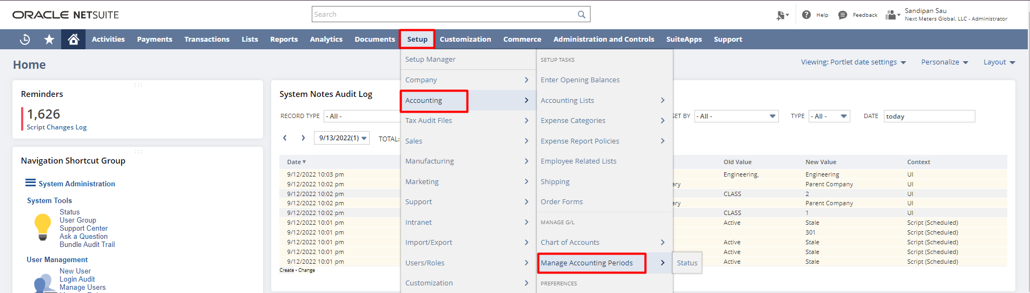

Closing an accounting period means changing its status from Open to Closed. Status of Closed indicates that posting transactions for the period have been completed. This status prevents posting to the general ledger for any dates included in the period, by anyone. Closing a period should be a final step, after a process of accounts review and reconciliation to ensure correctness and balance.

From the Period Close Checklist, you can close accounting periods.

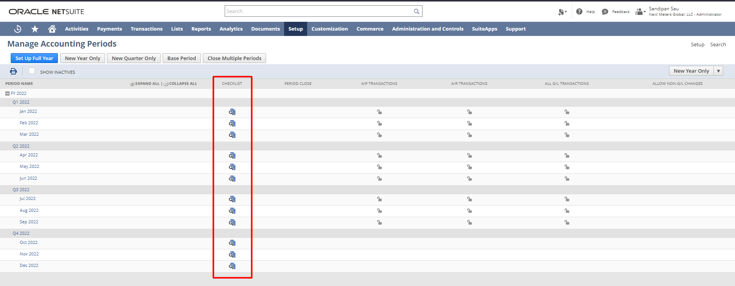

After clicking on the period close checklist, you will find a new window that will show you the Period Close checklist. From this checklist, you can complete required tasks in sequence and then close the period.
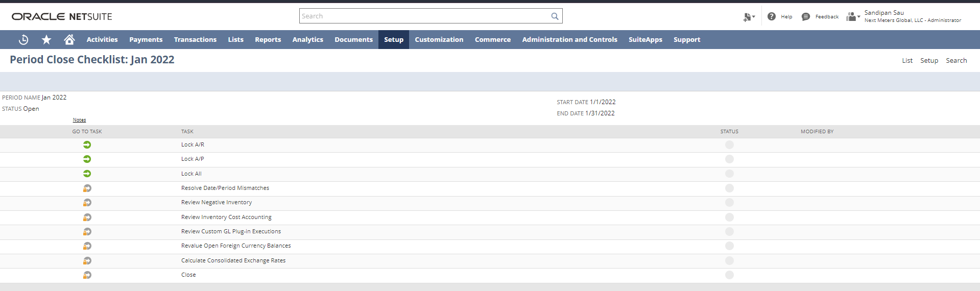

From individual tasks, you can close a period subsidiary-wise.

Segmentation:

Classes, Departments, and Locations are 3 ways to divide virtually all the information in NetSuite.

1. Classes:
Login to NetSuite using Administrator Role. Navigate: Setup -> Company -> Classes -> New
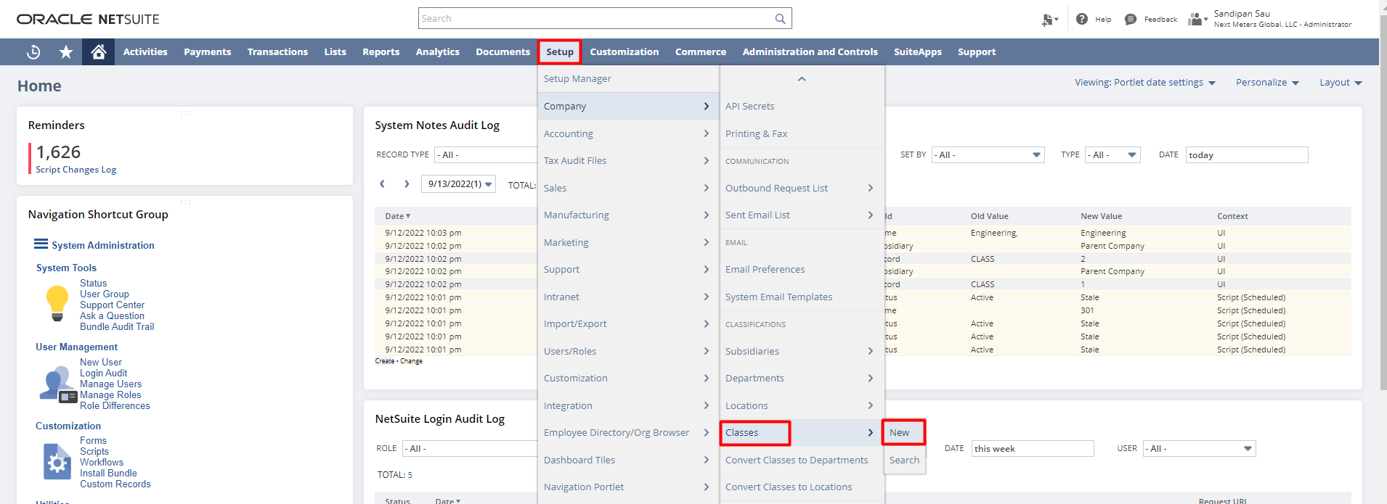

Classes are categories that you can create to track records such as financials, transactions, and employees. For example, you own a janitorial service and you want to track income and expenses separately for household and commercial accounts. You set up a class for each account type and track the financial performance of each class over any time period.

You can enter a class name, select a subsidiary as well as can select a parent class for a subclass.

Please note that using the ‘Include Children’ check box you can associate the class with all the subsidiaries associated with each subsidiary selected in the subsidiary field.
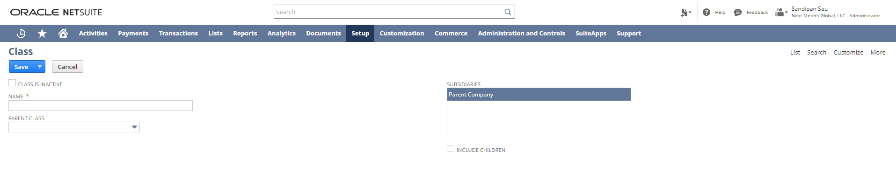

2. Departments:
Login to NetSuite using Administrator Role. Navigate: Setup -> Company -> Departments-> New

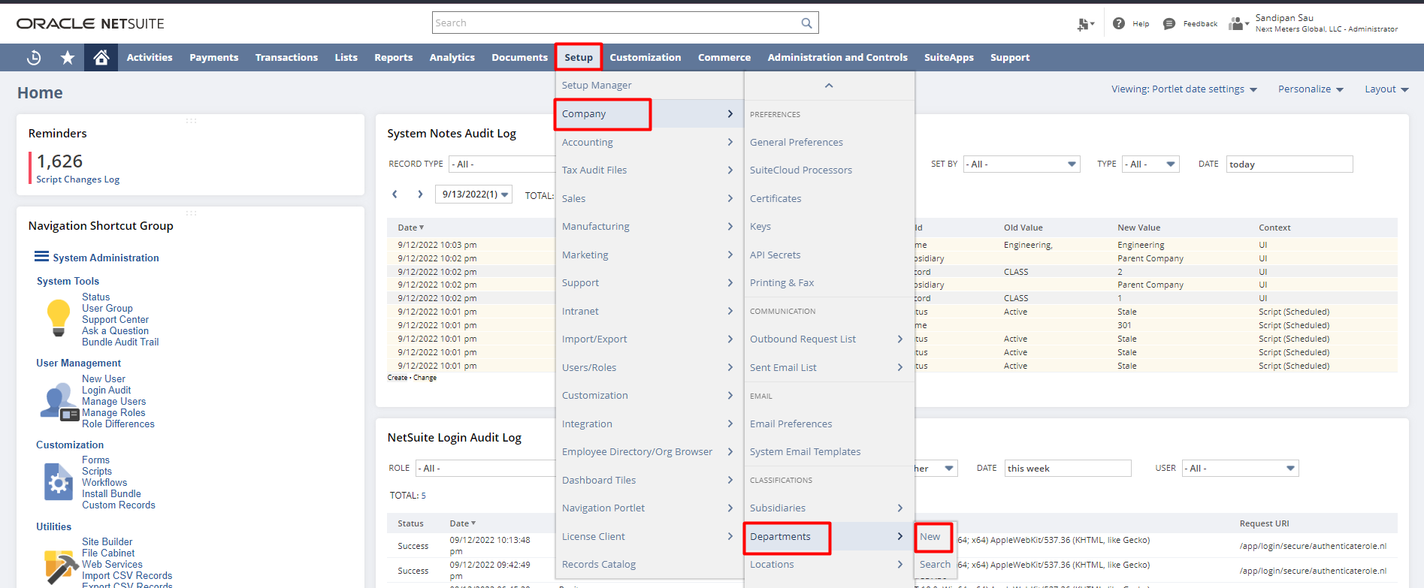

Departments are categories that you can create to separate and track records such as financials, transactions, and employees. For example, you can create a department for each team of employees dedicated to a certain area of business, and then track the income and expenses of each department over any time period.

You can enter a department name, select a subsidiary as well as can select a parent department for a sub-department.

Please note that using the ‘Include Children’ check box you can associate the department with all the subsidiaries associated with each subsidiary selected in the subsidiary field.

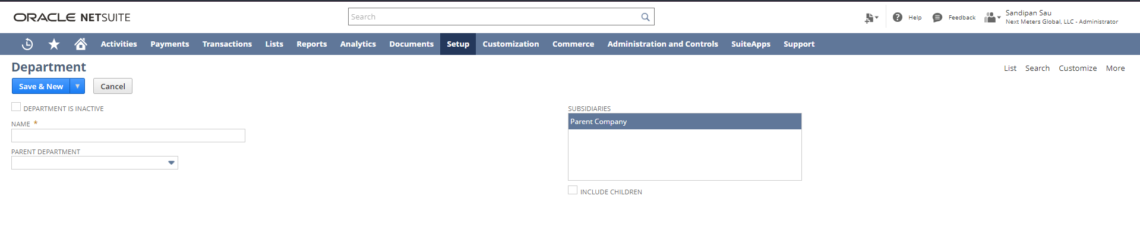
3. Locations:
Login to NetSuite using Administrator Role. Navigate: Setup -> Company -> Locations-> New

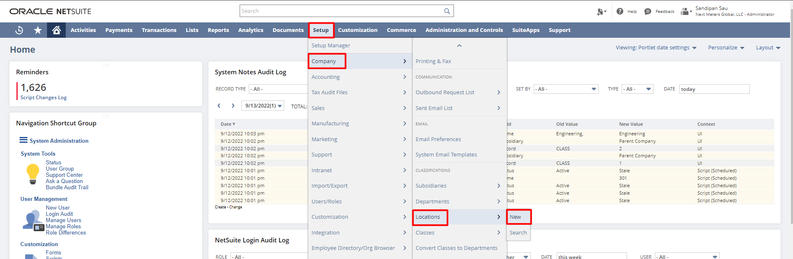

You can create a location record for each of your company’s locations. Then you can track employees and transactions by location. You can enter a location name, select subsidiary, select location type as well as can select a parent location for a sub-location. Using the ‘Make Inventory Available’ check box you can make on-hand inventory stored at the location available to orders. Using the ‘Use Bins’ check box you can track inventory bins at a particular location.

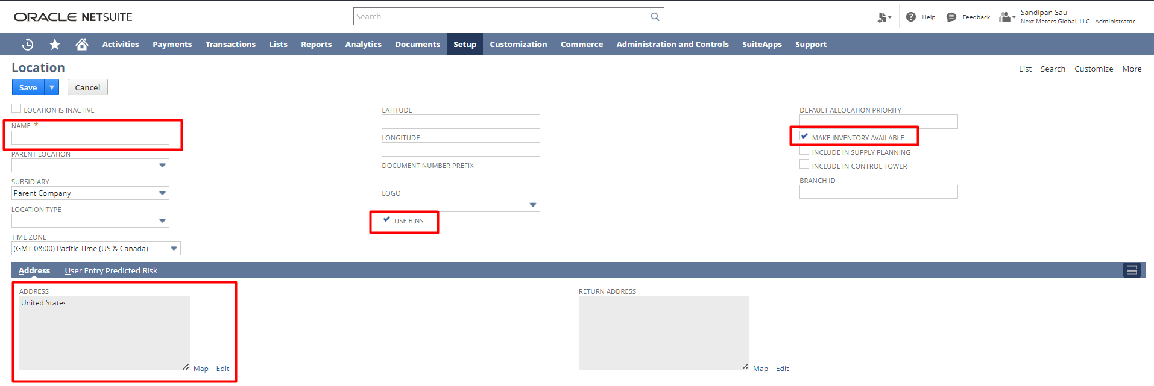

Nexus:
Login to NetSuite using Administrator Role. Navigate: Setup -> Accounting -> Nexuses -> New

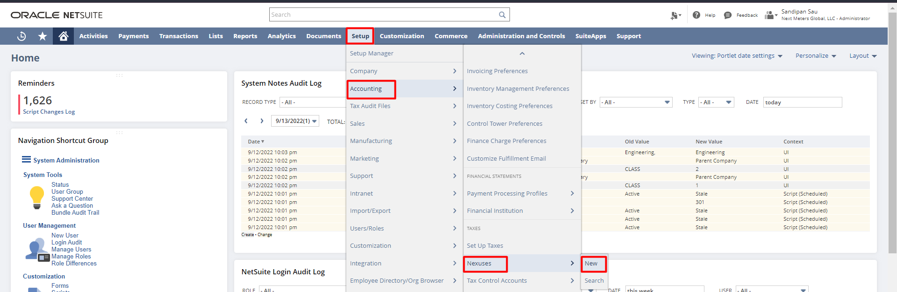

Nexus is a tax jurisdiction. Each subsidiary is associated with at least one nexus. The first nexus is automatically assigned to a subsidiary based on the company entered for the subsidiary’s address. A subsidiary can have more than one nexus. A nexus and its related tax items can be shared by multiple subsidiaries.
To create a nexus, enter the country name that you are making this nexus for, enter the description for this record and select the state/province/country that you are making this nexus for.
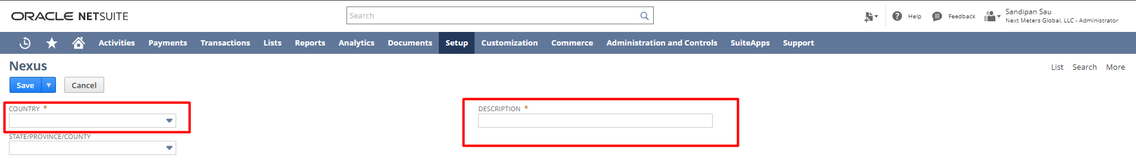

Tax Types:

Login to NetSuite using Administrator Role. Navigate: Setup -> Accounting -> Tax Types -> New

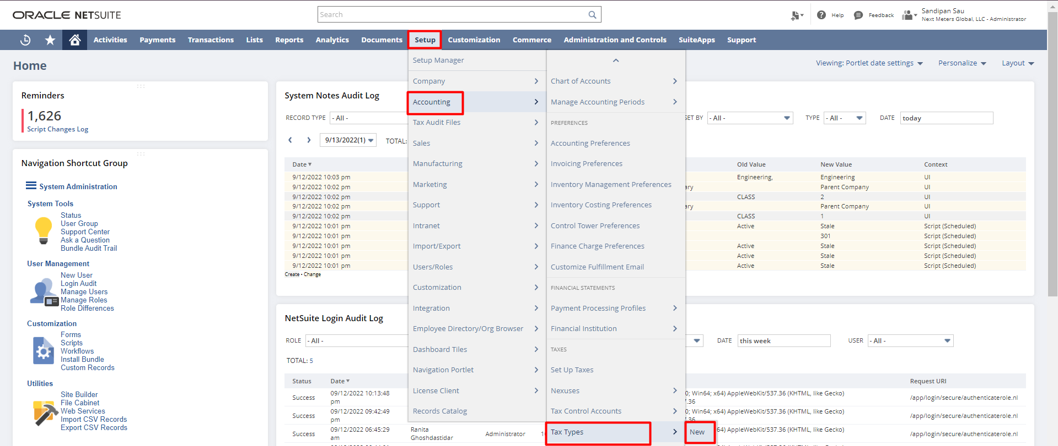

A tax type determines where the tax paid or collected is tracked on the balance sheet. In NetSuite, are either already set up by default, or set up for you by professional services. When
you add a subsidiary in a new country the tax type for that country becomes available in the system automatically. However, an administrator can create a new tax type if necessary.

To create a new tax type, enter a name or abbreviation for this tax type, enter a description of this tax type and from the Accounts tab, select the Liability/Sales Tax Account and Asset/Purchase Tax Account.

Tax Code:

Login to NetSuite using Administrator Role. Navigate: Setup -> Accounting -> Tax Codes -> New

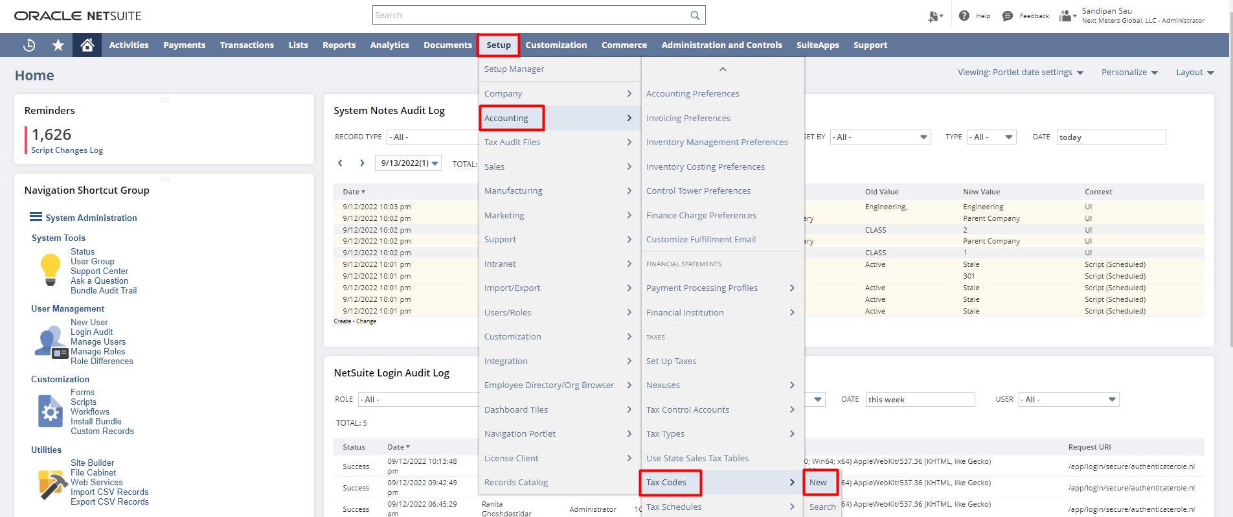

Tax codes determine how much tax your company must bill and pay on each transaction line item. In the UK Edition, NetSuite provides default tax codes. You can edit the properties in the tax codes, rename the tax codes, or create new tax codes.

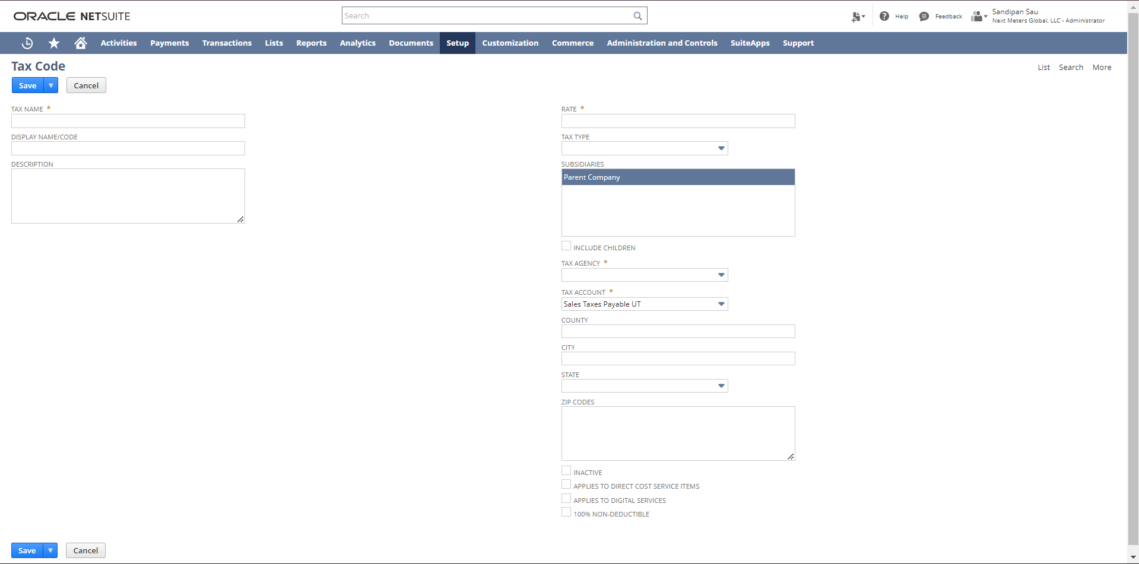

When you create sales or purchase transactions, you can apply this tax code to line items. To create a Tax code, enter the Name or an Abbreviation, Description, Rate, choose tax property like EC Code, applies to service items, Reverse Charge Code, Notional Rate Derived from, Export, Exempt, Default Code, Exclude from VAT Reports, etc. You can also select the Tax Agency that this tax is paid to, select the Tax Type for this tax code and select the types of transactions from the Available On the field that this tax code can be applied.

Tax Schedule:

Login to NetSuite using Administrator Role. Navigate: Setup -> Accounting -> Tax Schedules - > New

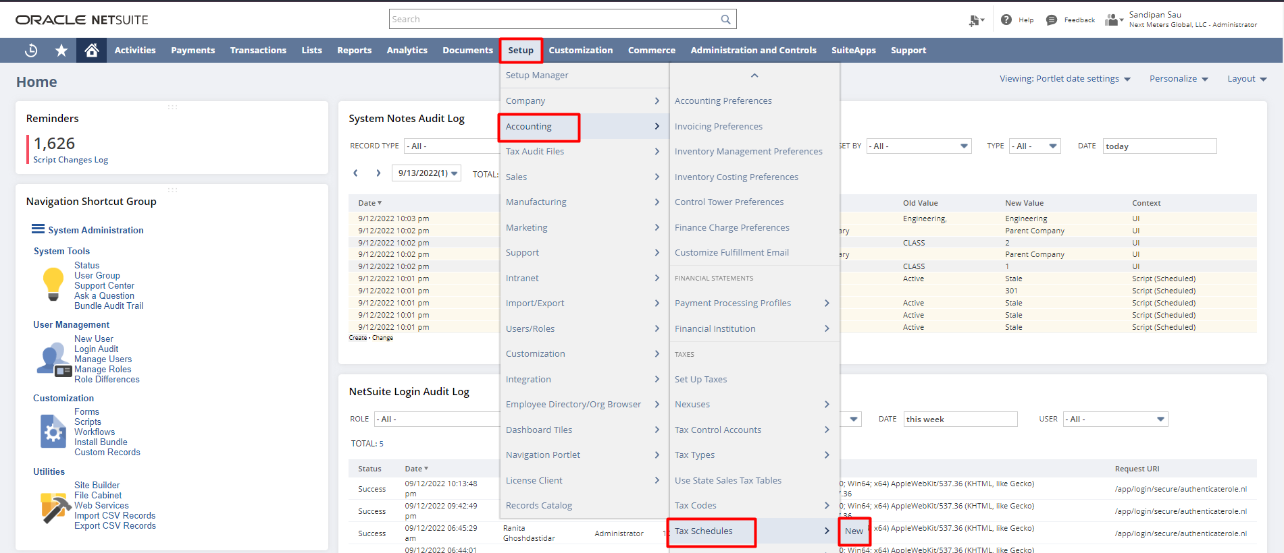

The tax schedule determines how NetSuite calculates taxes for items in each nexus. The Tax Schedule field on the item record is located on the accounting subtab, under Tax/Traffic information. The tax treatment for an item is determined by the tax code assigned to it.
To create a new Tax Schedule, enter the product field enter the name of the tax schedule that you want to associate with a product or item., description and select the sales and purchase tax codes to be used.

Chart of Accounts:

Login to NetSuite using Administrator Role. Navigate: Lists -> Accounting -> Accounts -> New
One of the first tasks you must complete before you can begin managing the account is to set up a chart of accounts. Your chat of accounts provides a set of destinations for posting transactions and categorizing transactions for tracking and reporting purposes.

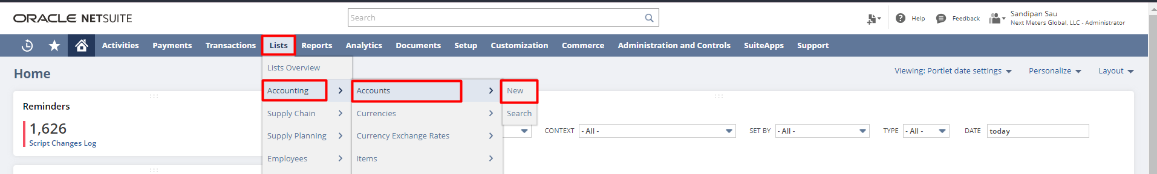

You can enter the account name and number, select account type as well as a subsidiary. Using the ‘Include Children’ check box you can share the account with all the sub-subsidiaries associated with each subsidiary selected in the subsidiary field.
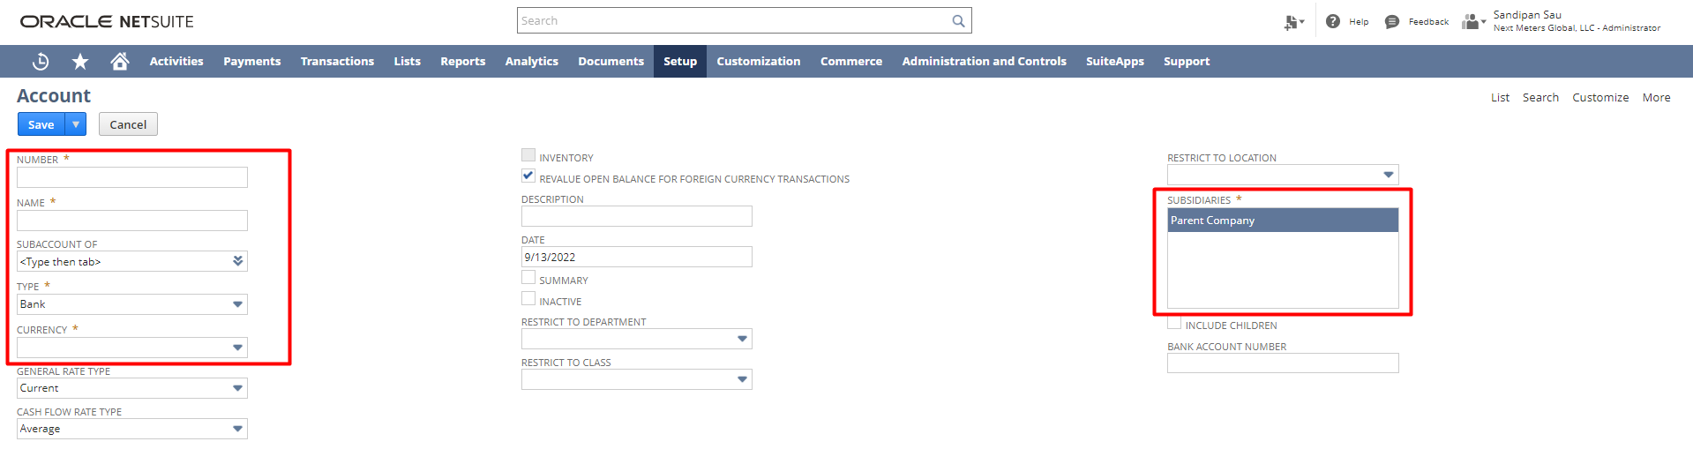

Journal Entries:

Log in to NetSuite using Administrator Role. Navigate: Transactions -> Financial -> Make Journal Entries

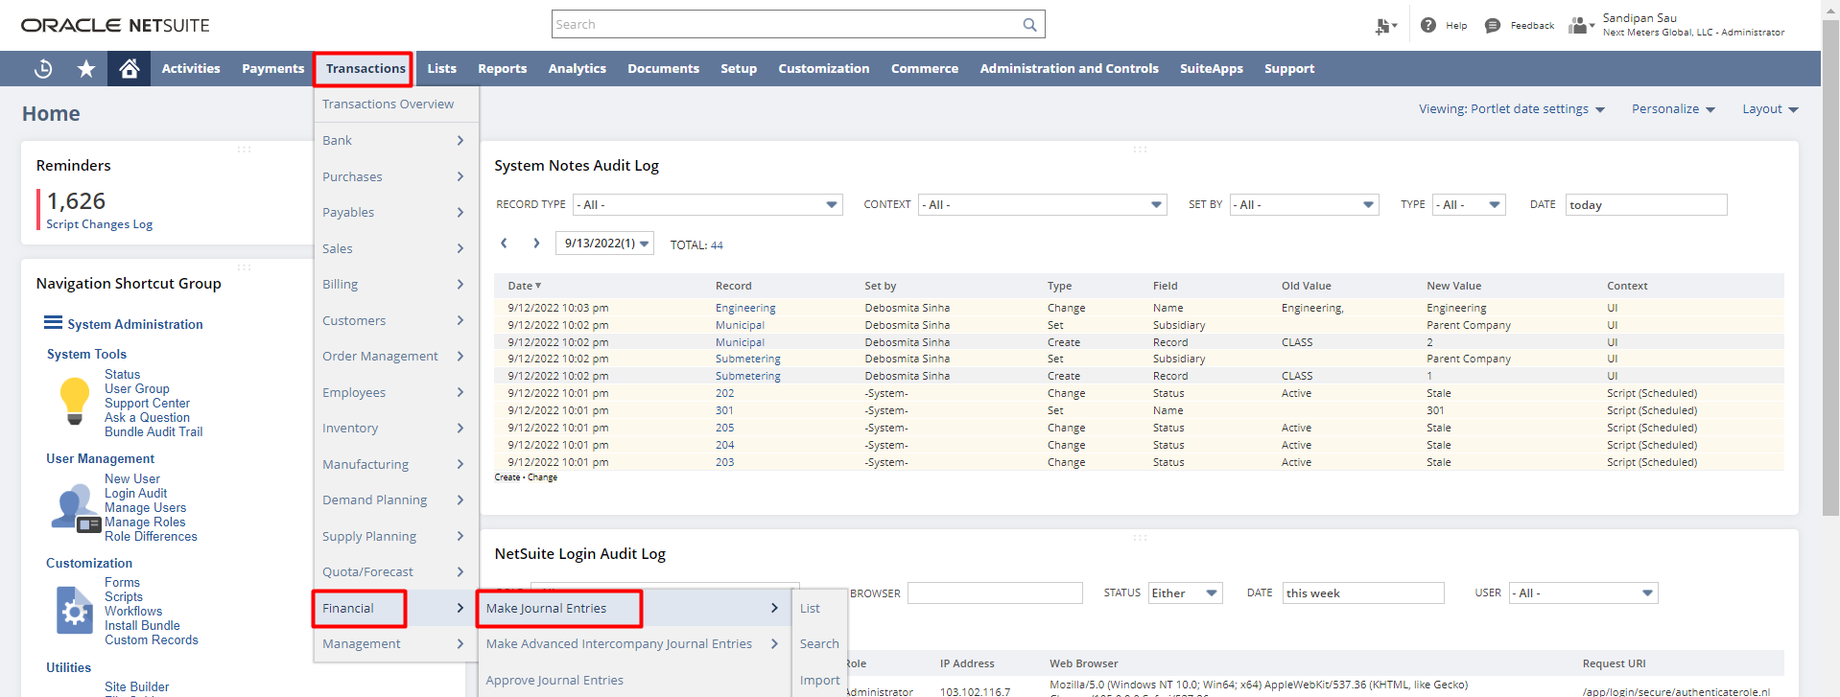

Use journal entries to adjust balances in your general ledger account without entering a posting transaction. Journal entry transactions are not posted until they are approved. A journal entry is posted in a period to which the journal entry approver has access. Until the journal entry is approved, NetSuite tentatively displays the posting period based on the transaction date, or, if this period is locked/closed, the first open period.

From the lines, subtab select the ledger account to be affected by this journal entry & enter the

Debit or Credit amount for each line.

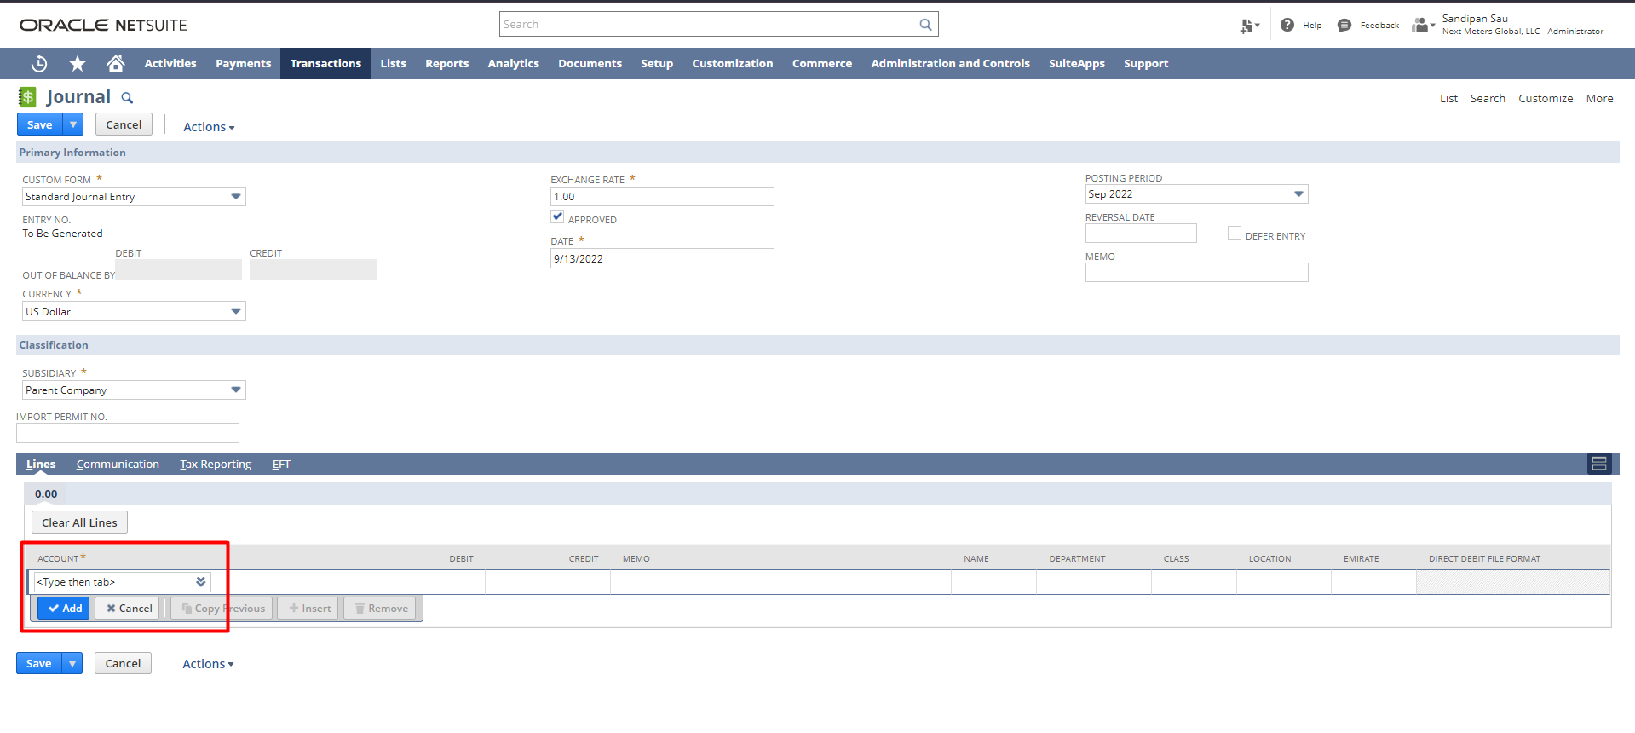

Budget:

Login to NetSuite using Administrator Role. Navigate: Transactions -> Financial -> Set Up Budgets

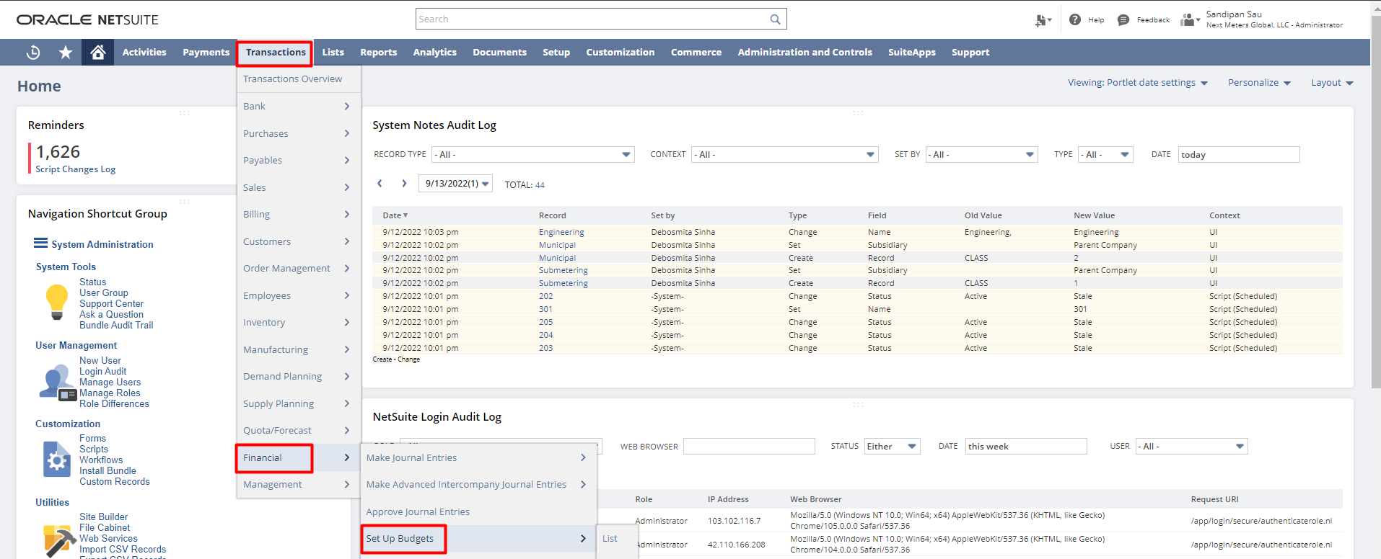

Each budget in NetSuite covers a fiscal year, for which you can enter an amount, per account, for each period. In NetSuite One World, budgets are specific to a subsidiary and fiscal year.
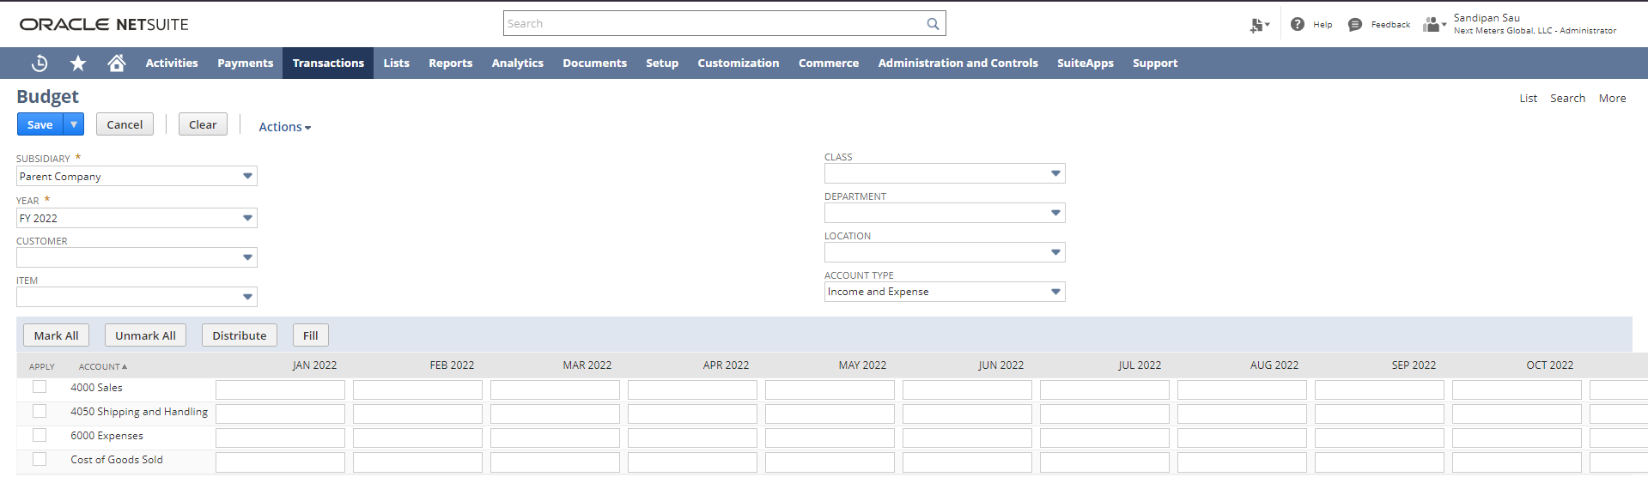
Write Checks:

Login to NetSuite using Administrator Role. Navigate: Transactions -> Bank -> Write Checks

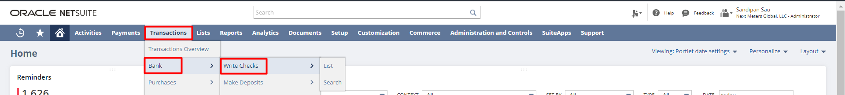

To create a new write check record, select a Payee, an Account that will be impacted. Enter the Date and the payment amount in the Amount field. Scroll down to Items/Expenses sub list, select an
Item or an Expense and enter the Rate/Amount. 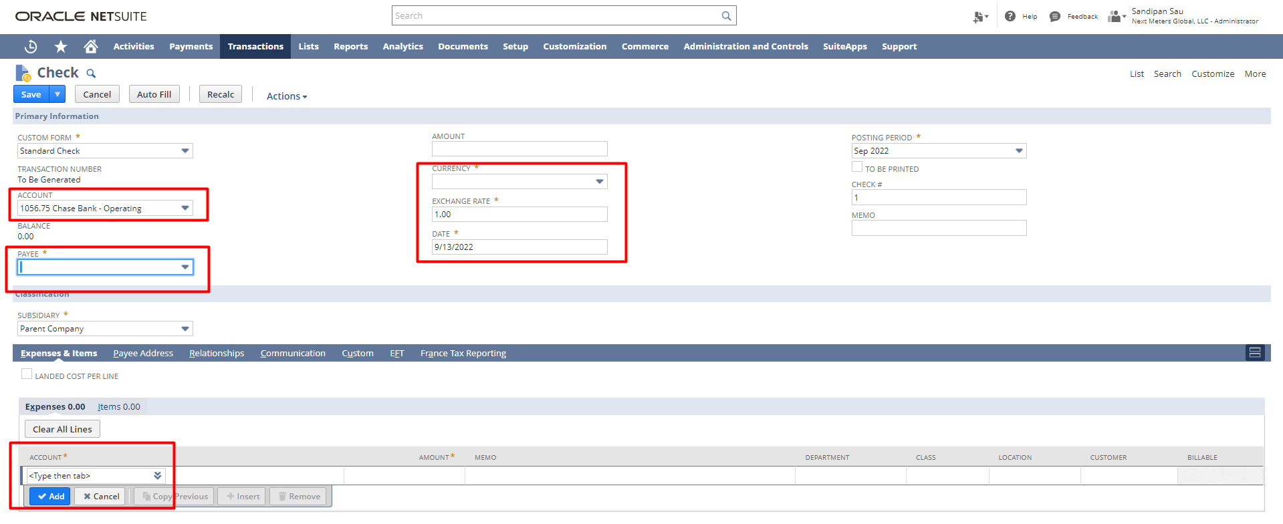

Make Deposit:
Login to NetSuite with Administrator role. Navigate: Transactions -> Bank -> Make Deposits.

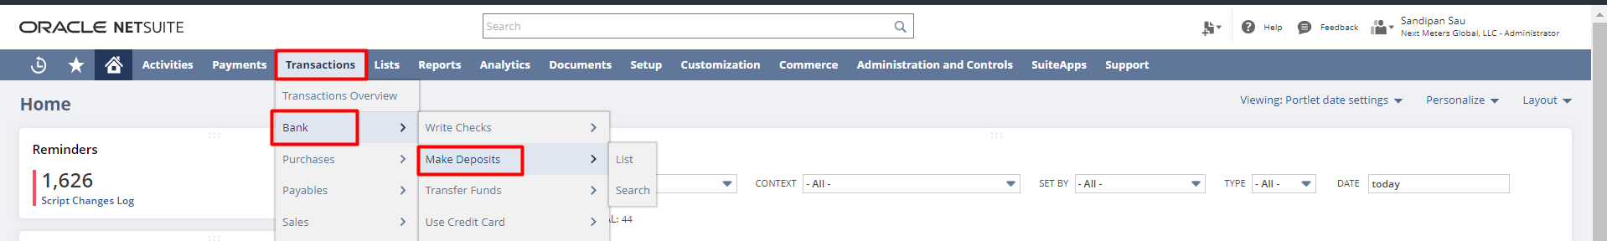

To make a new bank deposit record select an Account, and enter a Date. From the Deposits, subtab enters an Amount and Account in the Other Deposits sub-list.
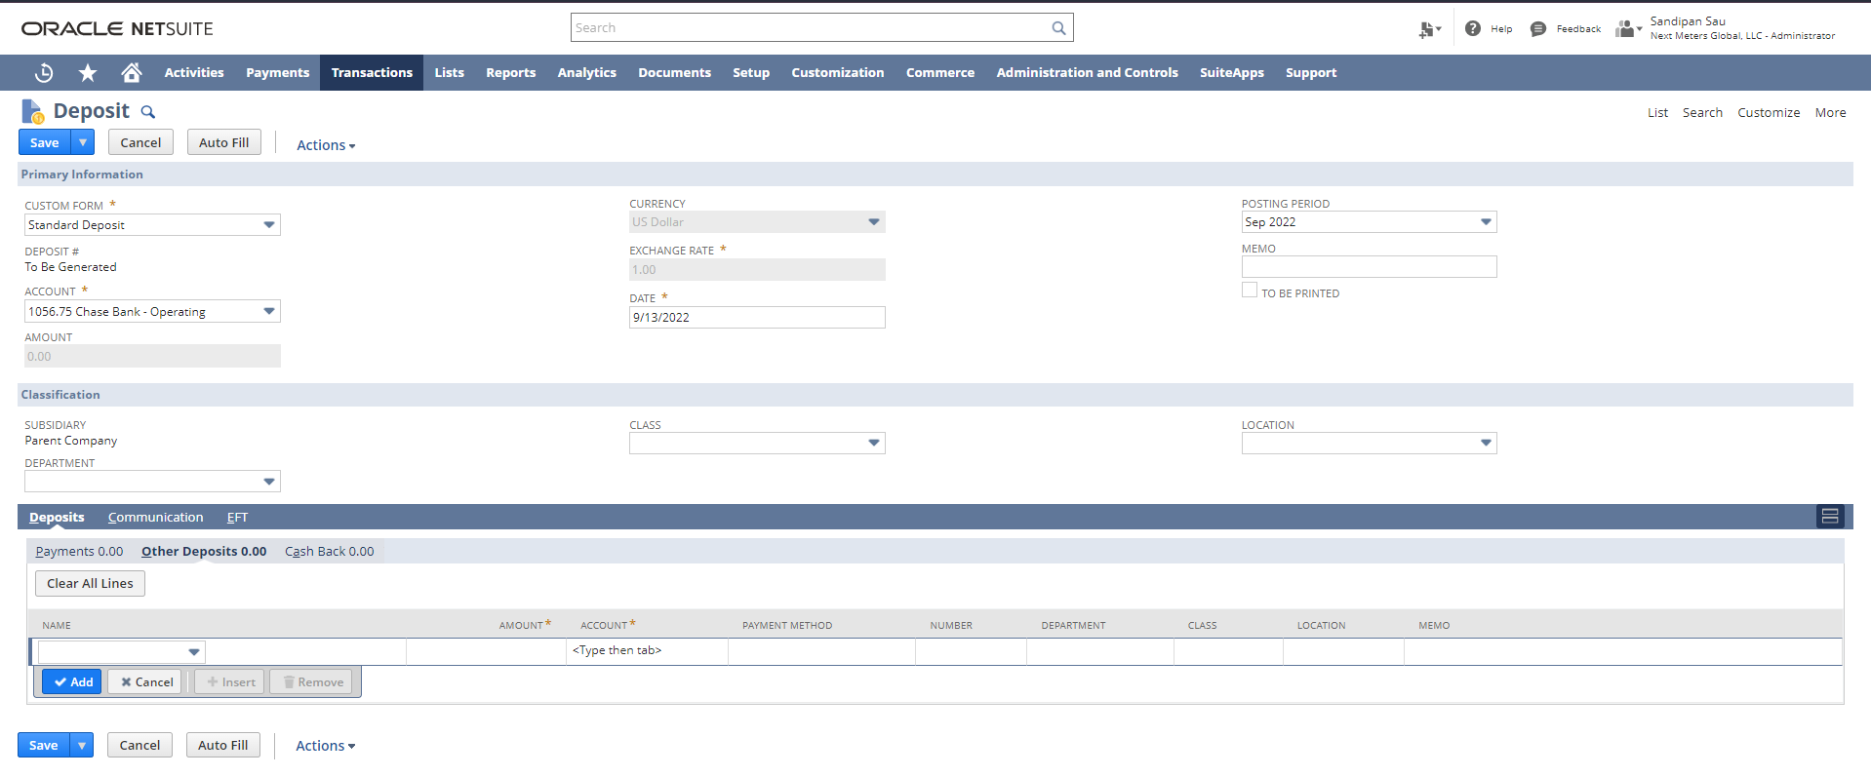
Use Credit Card:

Login to NetSuite with Administrator role. Navigate: Transactions-> Bank-> Use Credit Card.

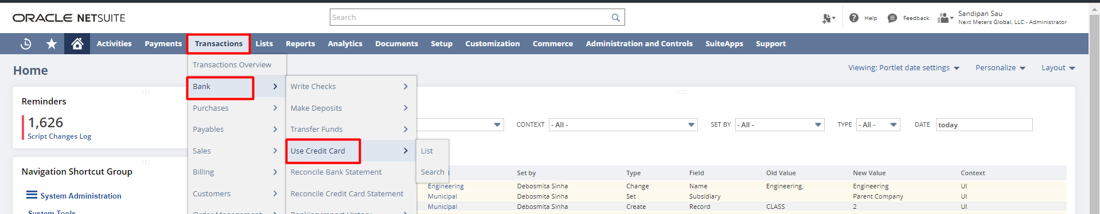

To create a new credit card transaction, select a Vendor from the dropdown, select the Account that will be impacted. Under the Expenses & Items, subtab select either an expense or Item and enter an Amount.

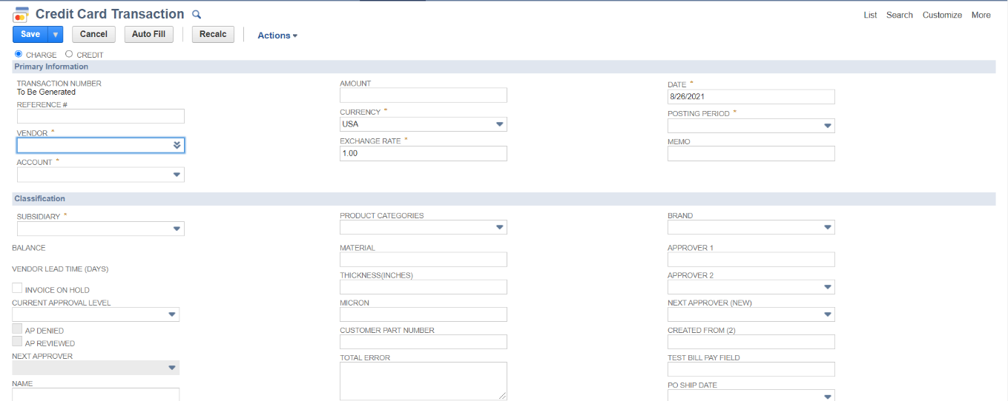

Also, select either the ‘Charge’ or ‘Credit’ option at the time of creating a credit card transaction record. If you are making a purchase, choose Charge. To record a credit to your account, choose Credit.
Reconcile Credit Card Statement:

Login to NetSuite with Administrator role. Navigate: Transactions -> Bank -> Reconcile Credit Card Statement.

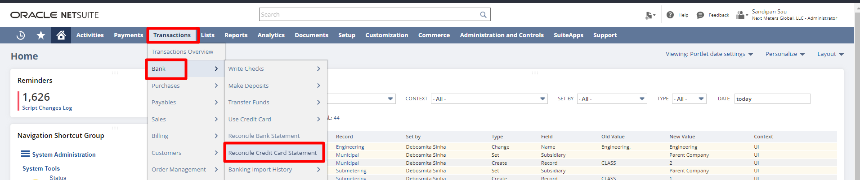

To reconcile a credit card statement, select the credit card account you are reconciling. The selected credit card account determines the default subsidiary and currency. This filters the open transactions at the line level. Check the reconcile checkbox for the Transactions you want to reconcile. The Last Reconciled Balance provides the balance of this account from the last time you reconciled your credit card statement. In the Start Date field, enter the beginning of the reconciliation period. Unreconciled transactions before this date do not display on the subtabs.

In the Ending Statement Balance field, enter the closing balance on the statement. The Reconciled This Statement and Difference fields update as you check the reconcile box next to transactions.

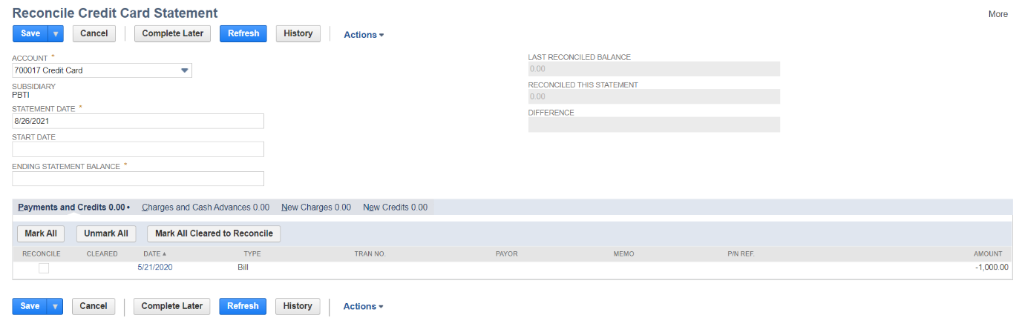

Reconcile Bank Statement:

Login to NetSuite with Administrator role. Navigate: Transactions -> Bank -> Reconcile Bank Statement.

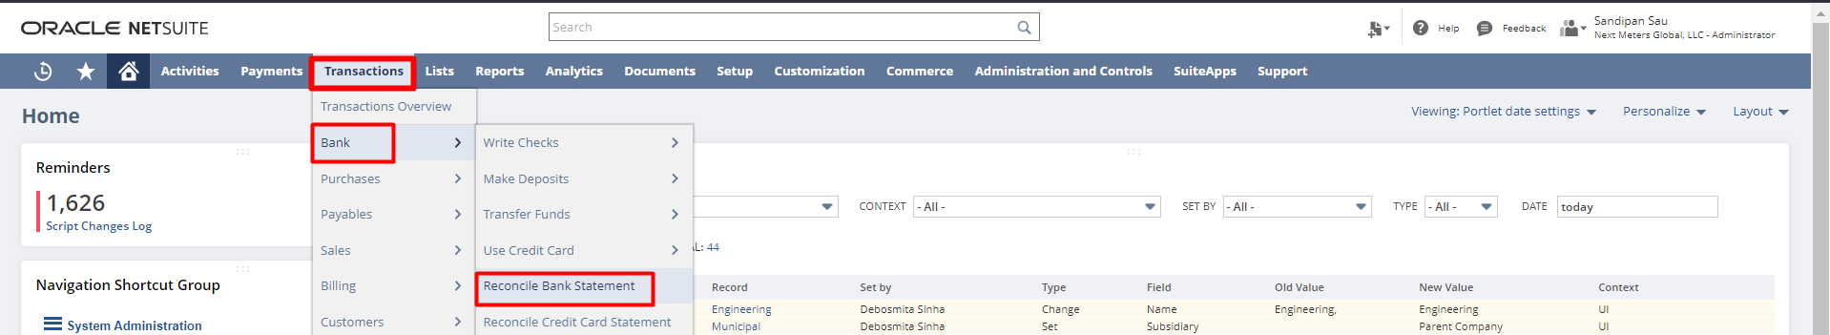

To reconcile a Bank Statement, select the bank account you are reconciling. The selected bank account determines the default subsidiary and currency. This filters the open transactions at the line level. Check the reconcile checkbox for the Transactions you want to reconcile. The Last Reconciled Balance provides the balance of this account from the last time you reconciled your bank statement. In the Start Date field, enter the beginning of the reconciliation period. Unreconciled transactions before this date do not display on the subtabs. In the Ending Statement Balance field, enter the closing balance on the statement. The Reconciled This Statement and Difference fields update as you check the reconcile box next to transactions. The Difference field displays the amount that you must reconcile (when the difference is zero, reconciliation is complete). NetSuite calculates the Difference field amount by subtracting the combined amounts of the Last Reconciled Balance and Reconciled This Statement from the Ending Statement Balance.
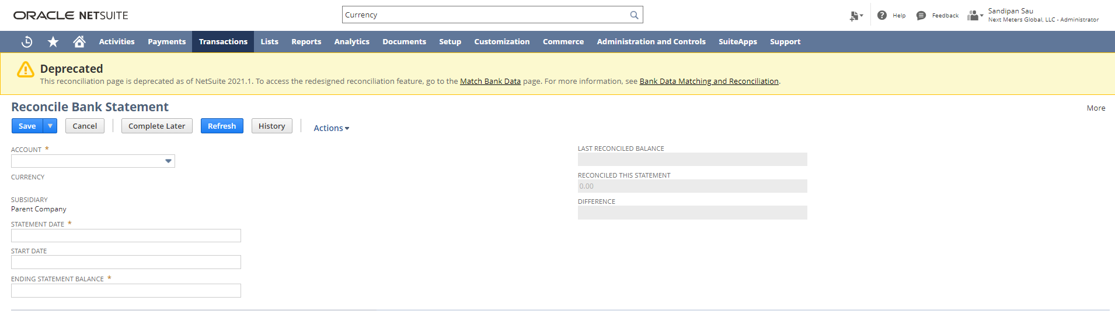

Currency and Exchange Rates:
Log in to NetSuite with Administrator role. Navigate: List-> Accounting -> Currencies

In NetSuite, you can create additional currency records for any other currencies to be used for transactions. NetSuite supports all ISO 4217 standard currencies.
To create a new currency record, enter the currency name in the Name field, enter. In the Default Locale field, select a country to determine the currency format. The ISO Code field displays the three-letter International Standards Organization (ISO) currency code for the Default Locale you select. You receive a warning if you change the value to an unsupported ISO code. Non-standard ISO codes significantly slow down the exchange rate update process.

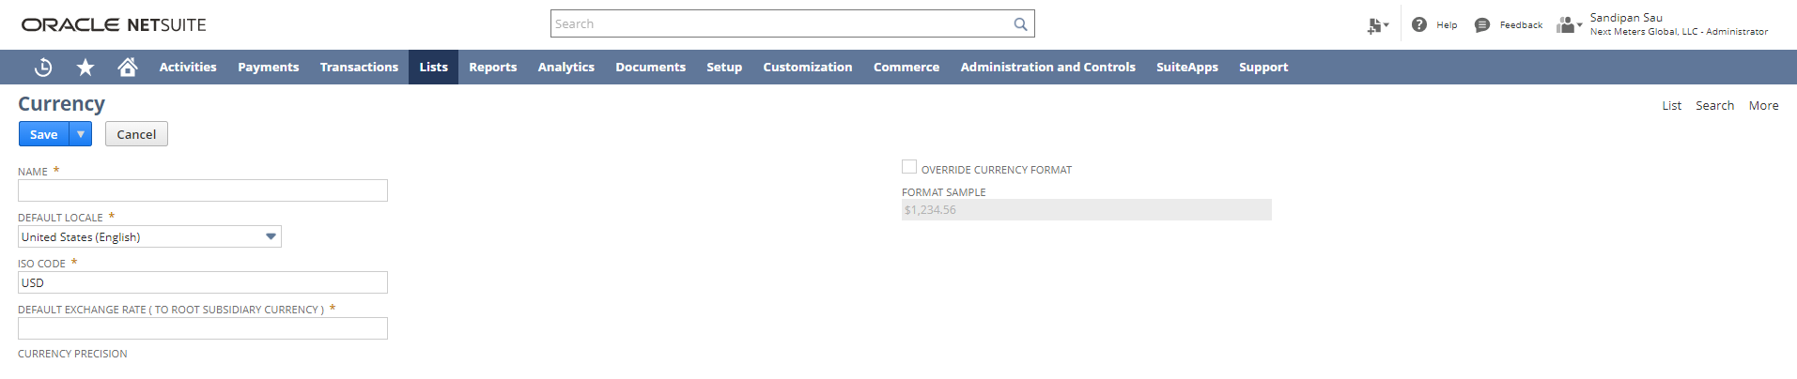

The Format Sample field displays the default currency format for the currency of the Default Locale.

In the Default Exchange Rate field, enter an exchange rate for this currency against the base currency of this company. To customize the format for this currency, check the Override Currency Format.

Disclaimer: Upon signing off on the process flow document, you are confirming that the process has been set up per the SOW within NetSuite per your business's needs. Any additional changes or modifications requested outside the initial scope of work could result in a change request at an additional fee.

*** PLEASE ensure that you have logged into NetSuite and tested the process prior to signing off on the setup. Paapri requires sign-off on this document prior to moving forward with any additional design meetings.

